Theoretical neuroscience: Conditional probability and signal-detection theory
Date: 19/12/19

I. Conditional response probability

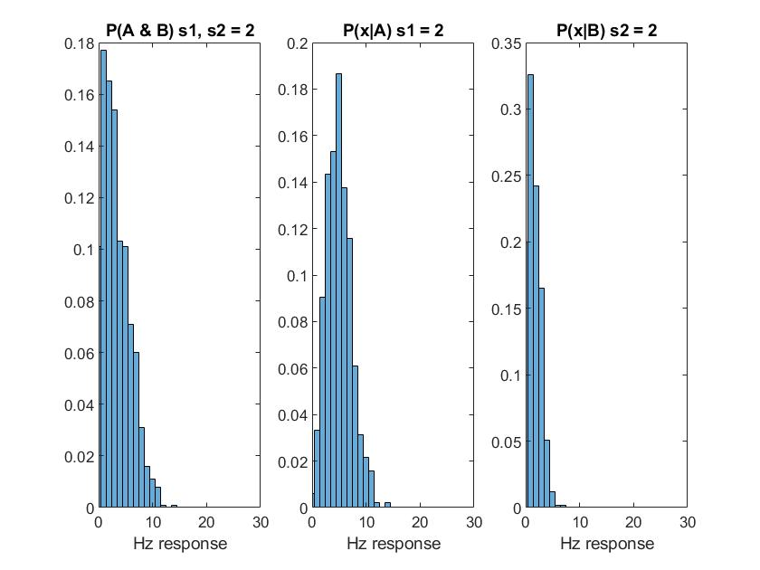

Figure 1: Neuronal probability responses to Stimulus Type A (Strength = 2) & Stimulus Type B (Strength = 2), 1000 trials.

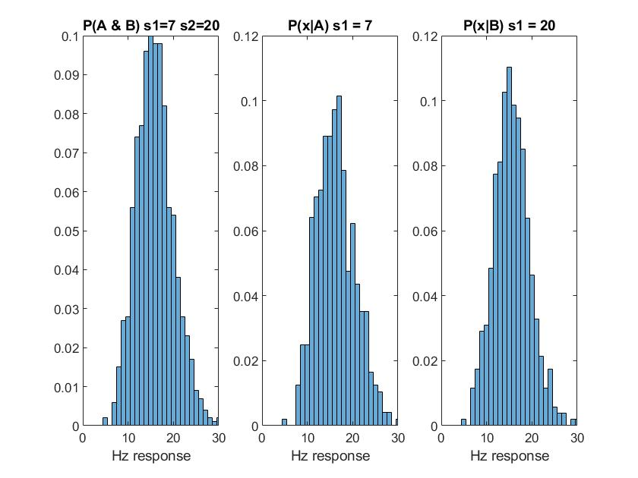
Figure 2: Neuronal probability responses to Stimulus Type A (Strength = 7) & Stimulus Type B (Strength = 20), 1000 trials.

How well do the responses distinguish between the 2 stimuli for different values of s?

As seen in figure 1, for the same stimulus strength, the neuronal response is higher for stimulus A than for B. Figure 2 shows that the frequency of the neuronal response is similar when the stimulus strength of A is 7 and when the stimulus strength of B is 20. This indicates that the neuronal response is more sensitive to stimulus A than B, thus distinguishing between the two stimuli.

II. ROC analysis
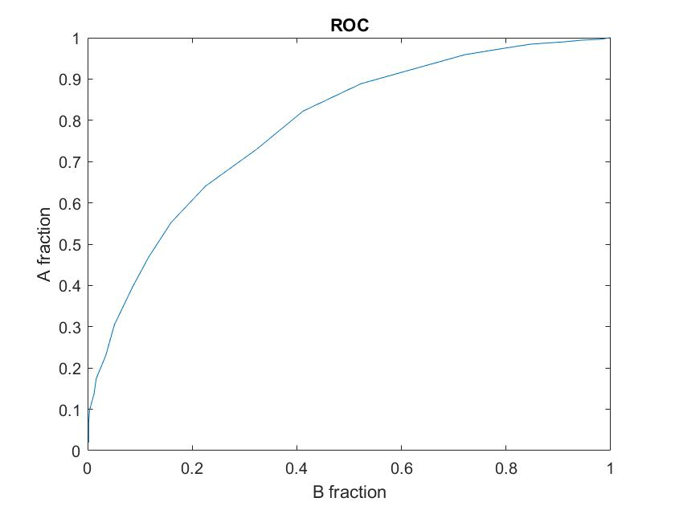
Figure 3: ROC curve for P(x| A) against P(x|B). Reliability (fraction correct)' = 0.7783 (AUC of above graph)

The ROC curve shows how the 2 stimuli can be distinguished as the criteria increases. Here we can see how distinguishable A is compared to stimulus B. Our reliability fraction supports this with AUC = 0.77.

III. Stimulus likelihood

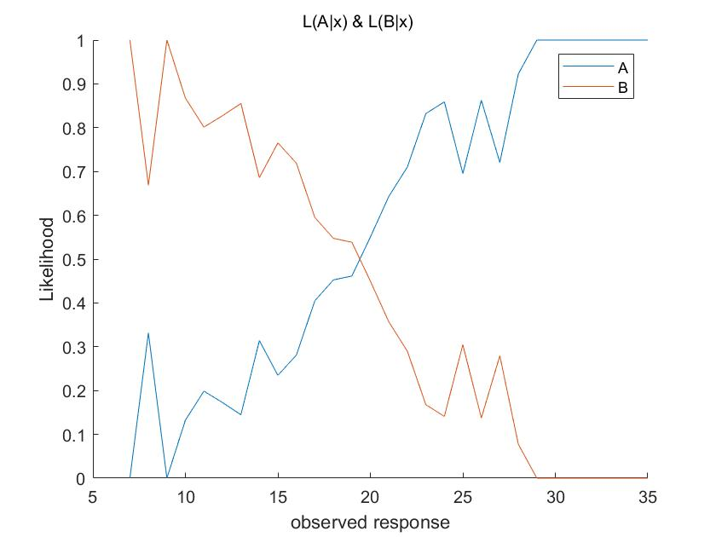

Figure 4: Likelihood of stimulus A or B, given an observed response (Hz).

Given an identical stimulus strength, the neuron responds differently to stimuli A or B. At approximately 20 Hz, there is an equal likelihood of the response being from either stimulus A or B (This can also be observed in Figure 5). The lower the frequency, the higher the probability of the stimulus being B and vice versa.

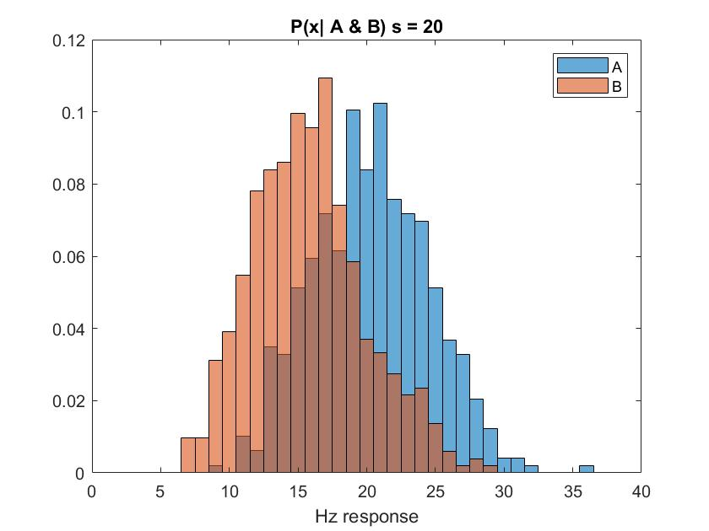

Figure 5 (Extra): Combined probability distributions for x response given A & B.

